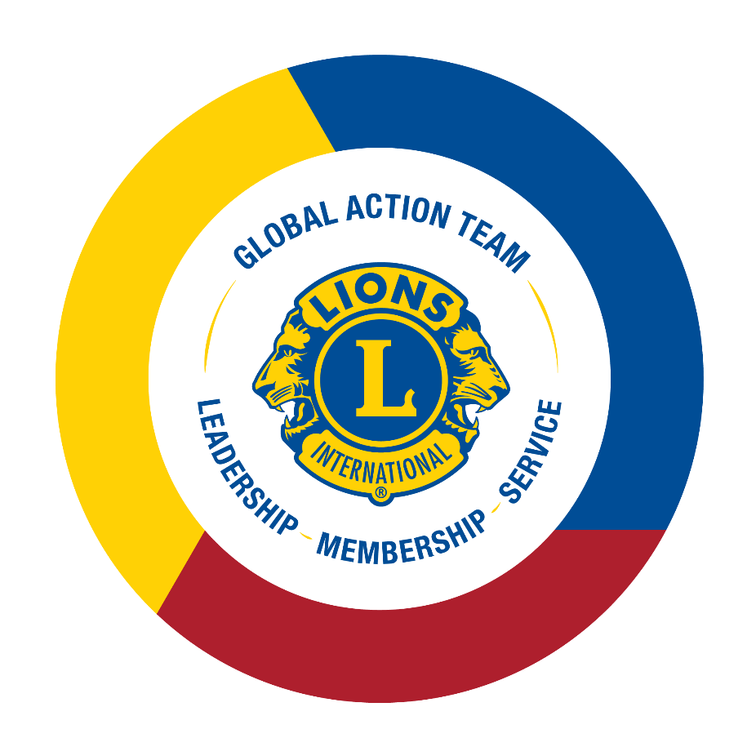

GAT Field Guide

Table of Contents
Core Expectations (MD/D) 3
Global Action Team History 5
Global Action Team Purpose 5
Benefits of the Global Action Team 5
Global Action Team Focuses 5
MISSION 1.5 5
District Goals 6
Global Membership Approach 6
Increase Lion Account Usage 6
Worldwide Reporting Days (WWRD) 7
Funding & Grant Opportunities 7
Leadership Development Grants 7
Membership Development Grants 8
LCIF Grants 8
Public Relations Grants 8
Marketing and Communication 8
Social Media 8
Blog 8
The Lions Brand 9
Communication Methods 9
Technology 9
Product Ambassador Program 9
Virtual Engagement 9
Lion Portal 9
Lion Account 10
eMMR 11
Resources 11
District e-Book 11
Club e-Books 11
Lions Learning Center (LLC) 11
GAT Landing Page 11
Lions Shop 12
Board Policy Manual 12
Take Action! Glossary of Action Words 12

Core Expectations (MD/D)

ONBOARDING EXPECTATIONS
☐ | Review Roles and Responsibilities.
☐ | Review GAT Field Guide.
☐ | Review district goals for your area using the ‘View/Print Goals’ link provided or through the District Goals Progress Dashboard on Insights.
☐ | Review important dates for financial opportunities, programmatic and leadership development support.
☐ | Review and understand training materials for the Lion Account, including any regional reporting tools, to support/promote use.
☐ | Review and understand the technology and communication needs of your area to support as needed.
☐ | Provide feedback on submitted district goals and action plans for your MD/district, including MISSION 1.5 targets.
☐ | Connect with your field team and follow up on plans for the term year.
☐ | Complete the Global Action Team course on the Lions Learning Center.
☐ | Join the Lions Global Action Team Facebook group and encourage your teams to do so as well.
☐ | Ensure that you and your teammates have a unique email address or phone number on file with Lions International. Talk to your club secretary to update your information.
☐ | Review the Global Membership Approach 4-step process PowerPoints and supporting resources, making notes of updates, including the addition of MISSION 1.5.
☐ | Review the Global Membership Approach course on the Lions Learning.

ONGOING EXPECTATIONS
☐ | Ensure MD, district, and club GAT understand their Roles and Responsibilities.
☐ | Commit to the organization-wide goal and objectives of MISSION 1.5, which includes achieving defined regional membership targets.
☐ | Sponsor at least one new member and extend at least one new club
☐ | Connect with clubs to ensure Service Activity Reports are being submitted.
☐ | Review progress towards district goals for your area through the District Goals Progress Dashboard and adjust plans as needed.
☐ | Ensure that you are communicating challenges and successes with your fellow GAT and respective teams to strengthen our impact.
☐ | Meet regularly with your MISSION 1.5 team and provide feedback on membership growth target attainment.
☐ | Apply for all appropriate Leadership Development, Membership Development, LCIF and PR grants.
☐ | Ensure zone chairpersons are engaging their clubs by sharing information, resources and offering district support to overcome challenges they may be facing.
☐ | Promote the optional role of the Global Extension Team Chairperson at the district level.
☐ | Ensure the Marketing Chairpersons are engaging their clubs by sharing information, resources and offering district support to promote service, membership and leadership opportunities.
☐ | Encourage Lions to create a Lion Account for access to platforms critical to their role and online trainings within the Lions Learning Center.

Global Action Team History
The GAT began as a series of separate teams, the Global Membership Team (est. 2008), Global Leadership Team (est. 2010) and Global Service Team (est. 2017), which were united in 2017 to form the Global Action Team.
In 2019, the Lions Clubs International Board of Directors resolved to further unify the teams by breaking down the GLT, GMT and GST silos at the highest levels of GAT to provide cohesive leadership across all levels of Lions. To further strengthen our service impact through membership growth, in 2022 the optional role of the Global Extension Team Chairperson was created at the district level to ensure new clubs goals of the district are met. Today, the Global Action Team is aligned to create lasting impact through action from the club level to an international scale.

Global Action Team Purpose
The GAT helps districts achieve their goals by creating a unified approach to all key areas of Lions. With the district’s goals at the forefront, the GAT is uniquely positioned from constitutional area to club level, to help foster positive membership growth in clubs, increase Lion’s visibility in the community through impactful service, and to build strong and innovative leaders in the districts. The GAT network of leaders directly supports districts in inspiring action at the club level. Additionally, the GAT champions the vision of Lions International and LCIF and will help reignite the passion for service in our Lions and Leos.

Benefits of the Global Action Team
Peer-to-peer support. The GAT consists of the people who know better than anyone what it takes to succeed as a Lion. By connecting with one another, the GAT shares local strategies, resources, and best practices across their peer network.
Global expertise. Local activation. GAT leaders have a direct line to association leaders and staff, providing access to globally proven strategies and resources that they can tailor to support local needs.
Authentic mentorship. GAT leaders model strong leadership and work closely with local Lions to develop and hone their leadership skills.
Goal-oriented. GAT leaders guide incoming district governors in the goal setting, planning and implementation process — the cornerstone of success for every district.
Connection. The GAT fosters strong connection points among local clubs and districts, creating an intricate network that connects local Lions to the global community.
The voice of Lions. GAT leaders from around the world share experiences and needs with Lions Clubs International headquarters to inform the development of effective tools, resources, and initiatives.
Storytelling. The GAT uses its expansive network to find and share meaningful stories of Lions that inspire and educate their fellow Lions.

Global Action Team Focuses

MISSION 1.5
Lions International is embarking on a new initiative to grow the association’s membership to 1.5 million Lions no later than July 1, 2027. MISSION 1.5 objectives are the following: all constitutional areas achieve positive net growth no later than fiscal year 2026-2027; all districts will add new clubs; all clubs will induct new members during MISSION 1.5; and districts will incorporate strategies to attract a more diverse membership. GAT constitutional area leaders and area leaders’ responsibilities will include training/tracking the success of their districts; providing resources and support; and being held accountable for achieving MISSION 1.5 targets for their respective CA/Area.

District Goals
The GAT helps districts to achieve their goals by creating a unified approach to action in Service, Membership, Leadership, and LCIF. As members of the GAT it is your responsibility to support the goal setting, planning and implementation process. Goals should be reviewed on a quarterly basis to ensure districts are on track to achieve their goals. Monitor and track progress of established, Service Activities, Membership Development (MISSION 1.5), Leadership Development and LCIF goals through the District Goals Progress Dashboard on Insights. In addition, membership goals established versus membership growth actuals for each district, multiple district, area, CA can be tracked via the Monthly Membership Progress Report. Updated reports for the 2023-2024 Lions year will become available starting August 1, 2023.

Global Membership Approach
The GAT is the driving force of the Global Membership Approach, which combines a strategic approach and a set of resources for district teams to utilize to attain MISSION 1.5 targets, develop membership and achieve a positive net growth by:
- Rejuvenating districts with new clubs
- Revitalizing clubs with new members
- Re-motivating existing members with fellowship and exciting service.
The approach has universal applicability, with the ability to customize based on regional needs and circumstances.
As members of the GAT, it is your responsibility to support the implementation of the Global Membership Approach, which includes: Build a Team, Build a Vision, Build a Plan and Build Success within your area. Work with your area leaders to learn more about the process and regional adaptations made to fit the needs of your area.
In 2021-2022, the GAT worked closely with those districts who were selected to participate in the pilot to create a regionalized process to best support the Global Membership Approach objectives in preparation for a worldwide expansion for the 2022-23 Lions year. More information and resources are available on the Global Membership Approach webpage.

Increase Lion Account Usage
Built to enhance the service of Lions, our digital products offer a wide variety of tools, resources and data for clubs, officers, and individual Lions. Access to each product depends on specific positions within clubs and the association.
All levels of the GAT can benefit uniquely from the platforms available which are outlined in the Technology section of this guide. GAT members should create a Lion Account and encourage their teammates to do so as well.

Worldwide Reporting Days (WWRD)
WWRD will occur three times a year between September – October, February – March, and May – June, prior to the Board of Directors meetings. CA leaders will meet with the Steering Committee, area leaders, group leaders and LCI staff to discuss the following agenda:
- Current Lion Year progress to MISSION 1.5 targets
- Barriers/Obstacles
- Support Needed
- Next Lion Year Goal Setting/Global Membership Approach
The process to submit reports in preparation for the calls is still in development. More information will be shared at a later date.

Funding & Grant Opportunities

Leadership Development Grants

Leadership Development Multiple District and District Grant Program
The Leadership Development Multiple District and District Grant Program provides funding to support expenses related to multiple district training of 1st and 2nd vice district governors and district training of zone chairpersons. Multiple district, sub-single district, or single district Global Leadership Team coordinators, on record with Lions Clubs International for the current Lions year, are responsible to submit the grant application and reimbursement form.
The Leadership Development Multiple District Grant provides reimbursement of up to US$100 per confirmed 1st vice district governor and up to US$75 per confirmed 2nd vice district governor (not to exceed actual expenses incurred).
Multiple District Global Leadership Team coordinators are highly encouraged to invite 1st and 2nd vice district governors from neighboring single districts to attend.
The Leadership Development District Grant provides reimbursement of up to US$500 per district for training of zone chairpersons (not to exceed actual expenses incurred).
District Leadership Development grant funding is limited – those who submit first will have priority.
If there is a provisional district in your area, contact your GAT Specialist for more information on available funding.
TAKE ACTION! Estimate your training dates and apply for relevant grants as soon as the grant application becomes available! You can always change the training dates later, if necessary.
To learn more about the multiple district/district grant application and reimbursement process, please contact leadershipdevelopment@lionsclubs.org or visit our webpage.

Leadership Development Institute Grant Program
All multiple districts, single districts and undistricted provisional districts/regions/zones, may now apply for a grant to support local institutes. Be sure to communicate with your multiple district or single district Global Leadership Team coordinator, as they are responsible to approve and submit the grant application and reimbursement form.
To learn more about the Institute Grant Program, please visit: https://lionsclubs.org/en/resources-for-members/leadership-development/institute-grant-program.

Membership Development Grants

Membership Development Grant Program
To support both recruitment and satisfaction of current members, the LCI Membership Development Committee offers Membership Development Grants on a competitive basis. These grants are meant to help regions capture new markets, particularly where membership has been declining. Multiple districts may apply for US$4,500 at a time and can apply up to two times per Lions year for a maximum amount of US$9,000. Districts may apply for US$1,500 at a time and can apply up to three times per Lions year for a maximum amount of US$4,500.
Please note: grant award amounts allocated per CA may vary.
For additional information on Membership Development Grants, please visit our webpage or email: membership@lionsclubs.org.

LCIF Grants
Lions Clubs International Foundation offers many grant programs, supporting the service of Lions across a variety of causes. The LCIF Grants Toolkit contains detailed information, including the specific criteria for each type of grant.

Public Relations Grants
Strong programs that make a difference in communities are key to effective public relations activities for Lions clubs. Available on a first-come, first-served basis, PR grants are a great way for Multiple Districts or Single Districts, to increase public awareness of Lions clubs activities and programs.
More information on PR Grants, including important deadlines, applications, and program details are available on our webpage.

Marketing and Communication

Social Media
GAT has a Facebook Group which is open to all Lions and Leos. Members from around the world share thoughts, discussions, and best practices, and Lions International provides real-time updates on important changes, deadlines, and programs.
Encourage your teams and clubs to join the Lions Global Action Team Facebook group.

Blog
The GAT utilizes the Lions Blog to highlight success stories that:
- Inspire readers through life-changing stories.
- Provide readers with expertise and “how-to’s.”
- Give readers opportunities to act.
Discover what Lions around the world have been doing and tell us your own story on our GAT Webpage.

The Lions Brand
The Lions Clubs International brand is recognizable throughout the world. Global brand guidelines and the Brand Advance Kit are available on the Brand Guidelines webpage to ensure the success of our visual and verbal identity.
The brand guidelines manual contains approved standard elements of the Lions Clubs International visual and verbal identity system.
The Brand Advance Kit provides logos, templates and other resources that your club can use when promoting itself and its events.

Communication Methods

Email
The GAT Chairperson, your constitutional regional or area leader, and Lions International will communicate important updates to the GAT via email on a regular basis. Emails are sent based on the information on file in LCI’s database, so be sure you have a unique email address on file.

Messenger Apps (WhatsApp/KakaoTalk/Line/WeChat)
GAT staff and field team utilize WhatsApp and other direct-messaging applications to communicate strategy and resources.

Facebook
Consider creating CA/regional/area Facebook groups to communicate with your teams.
Join the Lions Global Action Team Facebook group for important information and to engage with other leaders around the world.

Technology

Product Ambassador Program
Launched in 2020, the Product Ambassador Program is a smaller group of engaged Lions who work closely with staff at Lions Clubs International to provide constructive feedback that will help improve our digital products. Representing the majority of CAs, these Product Ambassadors serve as a conduit for sharing relevant resources and information with fellow Lions. Please contact your local GAT specialist for a list of Ambassadors in your area.

Virtual Engagement
COVID-19 has forever changed the way we live, work, and serve. Lions around the world are finding new ways to connect in their communities. GAT Leaders are encouraged to work with their Lions virtually to maintain member engagement.

Lion Portal
We're updating the digital tools you use as a Lion. To put it simply, we’re taking the functionality you have today with MyLion, MyLCI, Insights and other tools and combining them into one cohesive and consistent experience — the Lion Portal. The new portal, targeted to launch mid-2023, will offer the same features and functionality currently available, but with a more consistent and efficient experience.
Please continue to use the information listed below in the Lion Account to aid in navigating the platform until the Lion Portal launches.

Lion Account
A centralized platform for MyLion, MyLCI, Insights and Learn is now available. Take some time to explore and familiarize yourself with the system and let your GAT Specialists know if you have any questions.

MyLion
Use MyLion to connect with other Lions Clubs members, set up and promote club service activities, and discover projects in your area. The GAT regional field team will act as the conduit for MyLion education and toolkit resources to drive adoption of platform.
Consider hosting a local training on MyLion to familiarize your club officers with it.

Service Reporting
Report your service on MyLion. Sharing your impact is important to members, clubs and to our organization as a whole. Reporting can help chart progress and engage prospective partners. Capturing the information of all service projects, small or large, will demonstrate how clubs are making a difference.

MyLCI
Use MyLCI to review, maintain and update current membership in your district, view membership reports and monitor the progress of newly charter/status quo clubs. Review our newest report addition to MyLCI, ‘Current Recap of Account Balances’ (available to district leadership and above) to monitor and track which clubs in your area are at risk of falling into financial suspension.

Data Download
Club or officer data is available for download using the Data Download function on MyLCI. You may choose to download all data, contact information only or any combination of data fields. By default, all member records are downloaded. For additional information on how to use the data download function, contact your GAT Specialist.

Reports
Membership reports help GAT leaders monitor the membership growth and attrition trends within a 30-day time frame. These reports allow the assessment of the health of a multiple district and district to assist in the implementation of a strategic plan. Membership report resources can be found in the Membership Reports Toolbox or through MyLCI under the Support Center.

Insights
Insights provides LCI statistics and metrics for your area pertaining to membership and club development, service activities, and LCIF donations. You can also view Campaign 100 progress and Learn statistics in individual dashboards. Track and monitor your district’s progress to accomplishing their district goals through the District Goals Progress dashboard. Reach out to your GAT Specialists to request a PowerPoint for more information.

Learn
Accessing “Learn” will allow Lions and Leos to complete online courses via the Lions Learning Center, including the GAT course, obtain information about the Lions Clubs International hosted institutes, as well as view local training offered by their specific MD and district GLT coordinators.
In the Reports section of Learn, the My Learning Record report provides Lions with their individual training history as a participant and /or faculty.

eMMR
Some countries do not have access to certain technologies that we use here at LCI (mainly MyLion and MyLCI). For this reason, they may be excluded from certain communications and emails, or may require different messaging than other countries.

Resources

District e-Book
This District e-Book compiles essential information that is necessary for a successful term as a district governor. The e-Book provides easily accessible resources, links, guidelines, and board policies.

Club e-Books
Club e-Books are available for multiple roles at the club level. These documents have comprehensive guides to complete a successful term as a leader at the club level.

Lions Learning Center (LLC)
The LLC offers all Lions and Leos the opportunity to learn and sharpen their knowledge of Lions fundamentals and leadership skills through online interactive courses.
In addition to officer training and leadership courses, a Global Action Team course is available in the LLC. Access the LLC from the Learn app using your Lion Account.

GAT Landing Page
The GAT landing page contains GAT updates and resources, and links to toolboxes for service, membership and leadership.

Roles and Responsibilities
Roles and responsibilities are provided for constitutional area leaders, regional area leaders and area leaders in their appointment emails.
Multiple district, district and club roles and responsibilities are being reviewed at the June Board meeting and will be updated on the GAT Leadership page, at the start of each Lions year.

GAT Roster
A complete list of all GAT constitutional area leaders, regional area leaders, and area leaders with their assigned multiple districts, single districts and undistricted areas can be found on the GAT landing page.

GAT Overview PPT
A PowerPoint presentation providing a general overview of the GAT and team roles is available on the LCI website on the GAT resources page.

Success Story Webinar Toolkit
The GAT Resources webpage contains several tools that districts and clubs can use when hosting their own GAT Stories from the Field webinars including PowerPoint Templates, webinar timelines and promotional materials.

GAT Staff Contact Information
A GAT staff contact list is available on the website.
Directly contact the team at GAT@lionsclubs.org.
You can also reach out to your specific area’s staff be emailing the following addresses:

- CA 1: GAT.CA1@lionsclubs.org
- CA 2: GAT.CA2@lionsclubs.org
- CA 3: GAT.CA3@lionsclubs.org
- CA 4: GAT.CA4@lionsclubs.org
- CA 5: GAT.CA5@lionsclubs.org
- CA 6: GAT.CA6@lionsclubs.org
- CA 7: GAT.CA7@lionsclubs.org
- CA 8: GAT.CA8@lionsclubs.org

Lions Shop
Multiple district, district and club GAT leaders can purchase business cards and other items through our Lions Shop. These include, but are not limited to awards, pins, pens, banners, tablecloths and apparel.

Board Policy Manual
Be sure to review the Board Policy Manual after each Board meeting, as updates frequently occur. The Global Action Team’s information is located in Chapter XXIV.

Take Action! Glossary of Action Words
Inspire your team to create action through impact by incorporating action words into your communications and club promotions.

- Achieve
- Accomplish
- Advocate
- Activate
- Animate
- Bridging
- Cultivate
- Celebrate
- Champion
- Connect
- Create
- Determine
- Develop
- Drive
- Empower
- Encourage
- Energize
- Engage
- Facilitate
- Help
- Ignite
- Invigorate
- Inspire
- Join
- Leverage
- Monitor
- Motivate
- Momentum
- Nurture
- Organize
- Pivot
- Quantify
- Promote
- Recognize
- Share
- Steer
- Support
- Train
- Understand
- Unify
- Value

