

Second Vice District Governor Training
Instructor Guide

Impromptu Speaking Skills

Session background
The thought of public speaking intimidates many people. This fear is often diminished when there is time to prepare and practice before getting up in front of an audience. What happens, though, when there is not time to prepare? When you are asked to speak without notice? This can make the most confident presenters very nervous.

There will be many occasions in which second vice district governors will be asked to speak, sometimes with very little notice. The key to success in these situations is to have strategies they can use to compose their thoughts quickly and communicate their message clearly. In this session, second vice governors will recognize the benefits of impromptu speaking, learn tactics for thinking under pressure, and practice strategies to develop a speech within minutes.
Session Objectives

At the end of the session, participants will be able to:

- Recognize the benefits of impromptu speaking
- Anticipate situations during which you may be asked to speak
- Utilize tactics for thinking quickly in public speaking situations
- Prepare a speech with short notice using an impromptu speech template

Session Preparation

Preparation Suggestions

- Consider the technical requirements for the session. Test the laptop/computer, the LCD projector and screen, PowerPoint slides, and the wireless mouse/laser pointer, if appropriate.

- Conduct an inventory of the materials for the session. Utilize the Training Materials Checklist in the Instructor Preparation Guide to check that you have everything you will need for the session.

- Review all activities that will take place during the session. Have you obtained and organized all materials needed to complete the activities?

- Create a training schedule (optional). A copy of a suggested training schedule can be found in the Instructor Preparation Guide.

- Review content prior to the start of the session as a final measure of preparation.

Materials

- Instructor Guide
- Participant Guide
- PowerPoint Slides

Equipment

- Computer
- LCD projector and screen
- Flipchart and markers
- Wireless mouse/laser pointer (optional)

Action Icons



Refer to Participant Guide

Session Timeline

Section | Overview of Instruction | Materials
INTRODUCTION  (5:00) | Presentation/Discussion:  Session Overview | Participant Guide  PowerPoint slides
MODULE 1:  Impromptu Speaking Benefits & Opportunities  (10:00) | Presentation/Discussion: The Benefits of Impromptu Speaking  Presentation/Discussion: Anticipating Impromptu Speaking Situations | Participant Guide  PowerPoint slides  Participant Guide
MODULE 2:  Thinking Quickly Under Pressure  (20:00) | Presentation/Discussion: Tactics For Thinking Quickly Under Pressure | Participant Guide  PowerPoint slides
MODULE 3:  Preparing for Impromptu Speeches  (35:00*) | Presentation: Strategies for Impromptu Speeches  Activity: Give a 2-minute impromptu speech to participants in their group using an impromptu speech template | Participant Guide  PowerPoint slides  Participant Guide
CONCLUSION  (5:00) | Presentation: Public Speaking Resources and Session Summary | Participant Guide  PowerPoint slides
Total Time: 75:00

*Timing for this module will depend on the number of participants.

INTRODUCTION
Total Time: 5:00

Presentation: Session Overview (5:00)

Welcome participants to the session.

State
Consider the following scenario:

The district governor has asked you and the first vice district governor to attend the grand opening of a Lions youth center on his behalf. The youth center is sponsored by three Lions clubs in the district and is the culmination of 12 months of hard work. Along with Lions club members and members of the community, local government officials will also attend the event.

The first vice district governor is scheduled to say a few words and introduce the keynote speaker. An hour before the event you receive a call from the first district governor saying she is sick, and you will need to fulfill her speaking responsibilities. You have almost no time to prepare, and you’re worried you won’t know what to say. You feel your reputation and credibility are in jeopardy.

Ask
What would be your first reaction to this scenario?

Allow 3-4 participants to respond. Responses will vary, but may include feeling overwhelmed, anxious, fearful, panicked, or stressed.

Would you be ready to step in on a moment’s notice?

This is more of a rhetorical question but look for some signs that people feel they would not be prepared.

State
Many of us do not enjoy the opportunity to speak unexpectedly in front of an audience with little time to prepare. Feelings of panic, fear, anxiety, and stress are common in this situation and prevent us from being able to think quickly. However, this may not be an uncommon situation for second vice district governors. They may be expected to fill in when the first vice district governor is not available and may often be asked to speak with little notice.
Speaking with little time to prepare is called “impromptu” speaking. It is a type of public speaking that does not come naturally to many people but can be developed. In this session we will explore ways in which you can develop this skill so you can feel more confident when speaking at a moment’s notice.

Show
Display slide 1 and review the session objectives

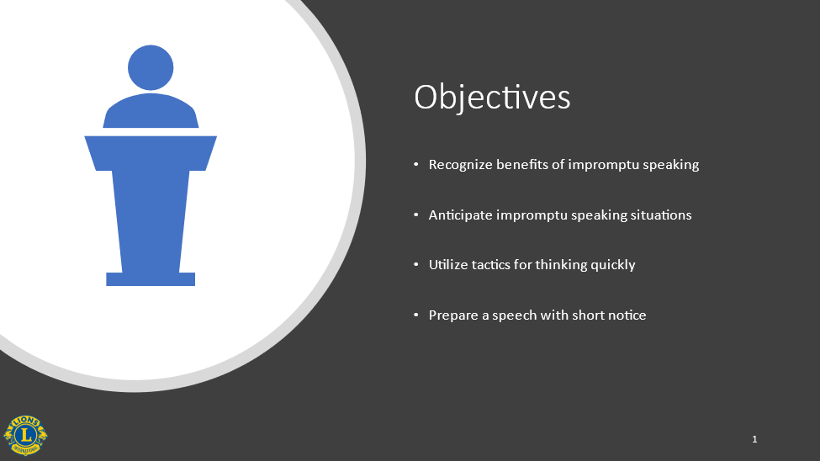

At the end of this session, you will be able to:

- Recognize the benefits of impromptu speaking
- Anticipate situations during which you may be asked to speak
- Utilize tactics for thinking quickly in public speaking situations
- Prepare a speech with short notice using an impromptu speech template

Transition
Before we learn some tactics and strategies for impromptu speaking, let’s first take some time to identify the benefits of developing this skill.

MODULE 1: Impromptu Speaking Benefits and Opportunities
Total Time: 10:00

Presentation/Discussion: The Benefits of impromptu speaking (5:00)

State
Impromptu speaking might sound like something to avoid whenever possible. It can be scary, nerve-wracking, and uncomfortable. Why voluntarily put yourself in situations that cause such anxiety?

Ask
How can developing your impromptu speaking skill be beneficial to you?
Refer participants to pg. 1 in the Participant Guide. They can record the responses here.

Allow 2-3 participants to answer. Answers will vary.

Ask
How might well-developed impromptu speaking skills increase your opportunities?
Refer participants to pg. 1 in the Participant Guide. They can record the responses here.

Allow 2-3 participants to answer. Answers will vary.

Show
Display slide 2: Benefits = Confidence and Increased Opportunities



State
Becoming skilled at impromptu speaking can give you the self-confidence you need to give a last-minute presentation, sail through a challenging meeting, or convince others of your ideas. You can build your reputation as a Lions leader when you learn to speak effectively under pressure. It can also help you conduct a successful question and answer session or make important connections at a networking event.

By developing this skill, you can learn to speak with eloquence, humor, and confidence, and you’ll ensure that you can communicate your messages clearly. This can be very advantageous as you pursue future leadership roles within the association.

Transition
So, how can you be ready the next time an unexpected opportunity to speak arises? You can start by anticipating these situations.

Presentation/Discussion: Anticipating situations in which you may be asked to speak (5:00)

State
As second vice district governor, you will be attending various engagements throughout your term. Although you may not be asked to prepare a speech ahead of time, you should anticipate that you may be asked to say a few words.

One common topic you may be asked to speak about at Lions events is the International President’s message on Lions global priorities for the year. It will be to your advantage to really understand the key parts of the message in order to share it with others and answer questions.

Additionally, as you head to an event, meeting, or club visit, you can do a few mental exercises and try to guess what you might be asked to say and how you would respond. Even if your guess isn’t correct, it’s amazing how those prior thoughts will help you think more quickly when you are asked to speak. It may even give you the confidence to volunteer to speak in order to practice your impromptu speaking skills.

Ask
As a second vice district governor, what are some situations in which you may be asked to speak unexpectedly?
Refer participants to the bottom of pg. 1 in the Participant Guide. They can record the responses here.

Allow several participants to respond and record their responses on a flipchart. Occasions do not always have to be formal events. They may be as simple as stating an opinion at a meeting or answering questions on a club visit. Encourage participants to think of any time they may be asked to speak without much preparation.

Examples may include:
- A scheduled speaker is unavailable
- Participating in a discussion panel
- Q & A after a presentation/club visit
- A telephone, radio or newspaper interview
- Saying a few words at a gathering
- Giving an update on a project
- Joining a debate about an issue in the district
- Giving an unplanned toast

State
As you can see from our list, there are several situations in which you may be asked to speak. All of these represent opportunities for you to improve your impromptu speaking skills. By thinking about these situations as “opportunities” and thinking ahead about what you might say, you can change the way you think about impromptu speaking. It doesn’t have to be stressful and avoidable…it can actually be exciting!
Transition
Anticipating situations in which you may be asked to speak is a great way to be ready for the unexpected. However, you may not always anticipate every situation, so having strategies for what to do when you are taken by surprise is another way you can be ready when an unforeseen opportunity to speak arises.
MODULE 2: Thinking Quickly Under Pressure
Total Time: 20:00

Presentation/Discussion: Tactics for thinking quickly (20:00)

State
When it comes to impromptu speaking, there are two different scenarios you may encounter. The first is being asked to share your thoughts, answer some questions, or give an update on a project without being warned ahead of time.

Consider the following situation.

You are attending your second district cabinet meeting. The district governor is sharing his concerns about an uncharacteristic drop in membership in some of the clubs in the district. He is unsure of the cause and wants to brainstorm some ideas on how to help these clubs recruit new members. Without notice, he calls your name and asks you to share your thoughts on the matter. With all eyes on you, you need to come up with something relevant to say. You want to gain the respect of the other cabinet members.

Ask
What are your thoughts on this scenario? Don’t worry, I won’t put you “on the spot” like the district governor did!

Allow 2-3 participants to answer. Answers will vary.

Show
Display slide 3: Thinking Under Pressure



State
You would likely feel under pressure if this happened to you! What do you do? What do you say? How do you say it? What if you can’t think of anything worthwhile to say?

You may have many ideas, thoughts and opinions running through your mind when you are singled out to speak in front of a group. The key here is to have some tactics to use so you can calm yourself down in order to convey your thoughts in a coherent manner.

Ask
What do you think is the first thing you should do when faced with a scenario like this?

Allow 2-3 participants to answer. Answers will vary.

Show
Display slide 4: Take a Deep Breath



State
The first thing you should do is pause and take a deep breath. A common mistake many people make is starting to speak before they have gathered their thoughts. While you probably can’t ask for a five-minute recess while you get your thoughts in order, a deep breath can give you a few more seconds to think. It slows you down, relaxes you, and makes you appear more in control of the situation.

Ask
What are some tactics you have used to calm yourself and gather your thoughts when faced with similar situations?

Refer participants to pg. 2 in the Participant Guide.

Give participants 5 minutes to discuss the question with those at their table and write down their tactics.

Allow one participant from each table to share one tactic their table discussed that is different from other tactics already given. Answers will vary.

State
You have all shared some great tactics you use when faced with an unexpected speaking situation. Before moving on to the second scenario, let’s review some common tactics that many people use to handle this type of situation (some of which you may have already shared).

Show
Display slide 5 and review tactics

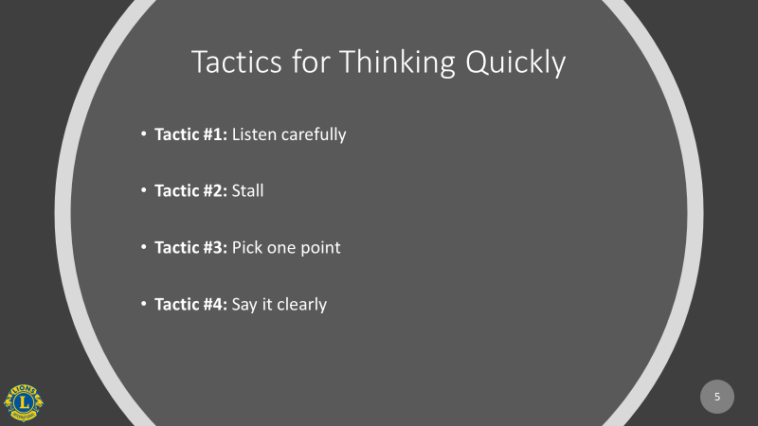

State
Tactic #1
- Listen carefully to the question and observe body language
  - Try to interpret what is being suggested by the question or request. Why is this person asking this and what is the intention? Is this an attack, a legitimate question for more information or a test?

Tactic #2
- Use stall tactics to gain time.
  - Repeat the question yourself before answering.
  - Narrow the focus by rephrasing the question or changing it slightly into what you want to answer.
  - Ask for clarification to force the questioner to be more specific.
  - Ask for a definition to make sure your understanding of the terminology is the same as the person asking the question.

Tactic #3
- Pick one point and one supporting piece of information.
  - Under pressure, you run the risk of sharing too much.
  - Don’t try to share all the ideas in your head, pick one main point and one supporting fact. This technique gives you focus and allows you to answer accurately and with conviction.

Tactic #4
- Say it clearly
  - How you say something is almost as important as what you say.
    - Speak in a confident voice (not just a loud voice!)
    - Use pauses strategically to emphasize a point
    - Vary your tone
    - Use eye contact
    - Pay attention to grammar/syntax

State
This type of scenario occurs often. Whether you are singled out while attending a meeting, offering a suggestion, sharing an idea, or answering questions after a presentation, clearly articulating your thoughts in unanticipated situations is a skill. When you convert your thoughts into coherent speech quickly, you ensure your ideas are heard. You come across as being confident, persuasive, and trustworthy. The more you practice, the better you will get!
Transition
Now that we have a good idea how to handle times when we are caught off guard and asked to quickly respond, let’s move on to the second scenario: being asked to deliver a more lengthy speech without much notice.

MODULE 3: Strategies for Impromptu Speeches
Total Time: 35:00

Presentation: StratEgies for Impromptu Speeches (8:00)

Instructor Preparation Note: There is an acronym used in Strategy #1 of this module that may not translate. If this is the case, you may have to reword the paragraph to remove the acronym and just explain the four parts of the template. This acronym is also found in the PowerPoint. This will have to be updated before facilitating the session.

State
Think back to the scenario from the beginning of our session. There will be times as second vice district governor when you will have to deliver a last-minute speech. You may be called upon to do this because the first vice district governor is unavailable or because you are visiting a club or attending a meeting and those in attendance want to hear from you.

State
In these cases, you typically have more than a few seconds to prepare your thoughts, but maybe not much more. What if you only had five minutes to put together a 5–10-minute speech? Would you know what to do?

Like the tactics discussed already for thinking quickly under pressure, some of which may also come in handy here, there are strategies you can use to help you prepare for impromptu speeches.

Show
Display slide 6: Strategies for Impromptu Speeches

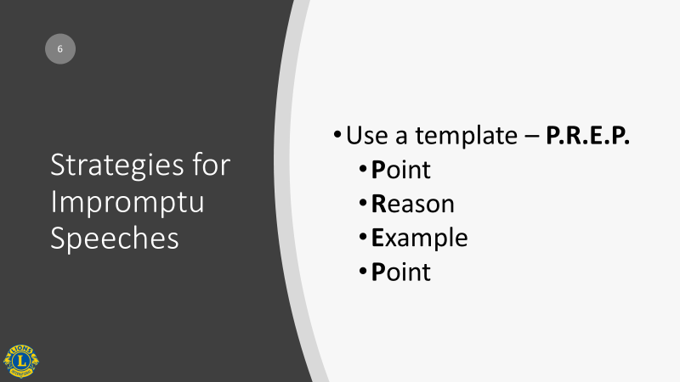


State
Refer participants to pg. 4 in the Participant Guide.

Strategy #1
- Use a simple template or framework to organize your thoughts.

Several templates have been developed to help people organize their thoughts quickly to deliver an impromptu speech. One of these templates is called the P.R.E.P. method. The acronym stands for Point, Reason, Example and Point.

- Start off by clearly stating your point or position.
- Share the primary reason (or reasons if you have more time).
- Share an example or examples, preferably in story form, where your main point or reason is supported.
- Conclude by summarizing your main point again.

This template works well in many situations and is easily adapted. We will use this template to practice our impromptu speaking skills later in this session.

Show
Display slide 7: Strategies for Impromptu Speeches

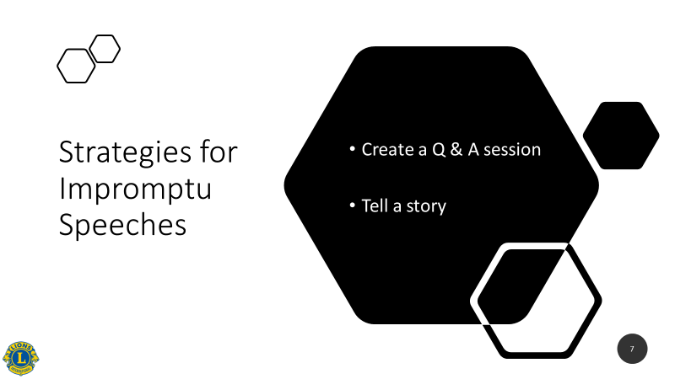
State
Strategy #2
- Turn your impromptu session into a question & answer session.

In situations where you are asked to fill in for an absent speaker, it may not be wise to launch into a 45-minute impromptu speech. Even the most accomplished speakers are prone to falter in that situation. Instead, reframe the session as a Q&A session, which breaks it up into a series of very small impromptu speeches that are easier for you to manage. Plus, the content comes directly from the audience, so you are guaranteed to deliver what they are seeking. You may also deliver a short speech and then take questions.

Strategy #3
- Use personal stories.

Storytelling is an essential skill for prepared speaking but is equally useful for impromptu speaking as well. Stories are emotional, real, and interesting. If you stick to personal stories that relate to the topic and audience, you’ll find that it is much easier to speak without preparation, because the events happened to you.

Transition
The best way to be to be prepared for an impromptu speech is to practice. The more you practice the more comfortable you will become using the various strategies.

Activity: Using an impromptu speech template (27:00)

Instructor Preparation Note: Depending on the number of participants in your training, this activity may take less time than noted. The time estimate is based on four participants in a group being given 5 minutes to prepare their speech and 2 minutes each to deliver their speech.

State
Let’s take some time now to practice using the impromptu speaking template we just learned. Don’t worry, you are all here to support one another, so give it your best and don’t be afraid to make a mistake. We are all learning together.

Activity Directions:

Divide participants into groups of no more than 4.
Review the impromptu speech template at the top of page 5 in the Participant Guide.

Give the following directions:

- Each participant will pick a speech topic from page 5 in the Participant Guide.

- You will have 5 minutes to organize your thoughts on the topic using the impromptu speech template and write down any notes you wish on the bottom of page 5. Do not write out exactly what you are going to say, just bullet points.

- Each person will then be given 2 minutes to give a speech to the people in their group on the topic they have chosen. Select 1 person in each group to be the timekeeper.

Give the participants 1 minute to choose their topic.

Begin the “speech preparation” time.

Call time after 5 minutes.

Have each group decide who will give the first speech and have all other participants close their Participant Guides and pay attention (so they do not continue to prepare for their own speech). Each table is responsible for keeping time for each speech.

Begin the speeches.

Call time after 12 minutes (or when all participants have given their speech).

Take 5-7 minutes to debrief. Ask how the speeches went and if the template helped them to organize their thoughts.

Transition
Don’t be discouraged if your speech did not go as well as you wanted. It takes practice to become a good impromptu speaker. Now that you know a template you can use, continue to look for opportunities to practice.

Transition to the conclusion.

CONCLUSION
Total Time: 5:00

Presentation: Public SPEAKING RESOURCES and Session Summary (5:00)

Show
Display slide 8: Resources

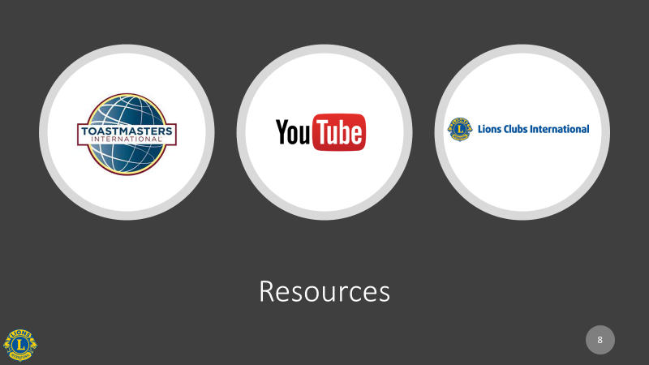

State
Refer participants to pg. 6 in the Participant Guide.

One of the best ways to practice impromptu speaking is by joining a Toastmasters Club. Toastmasters International has clubs around the world dedicated to helping people build their communications and leadership skills in a low-threat environment. While all clubs have their own personality and overall approach, in every case, some attendees are asked to give impromptu remarks at every meeting. The supportive nature of the meetings, low pressure and varied opportunities to speak make Toastmasters a great way to learn and practice the skills of impromptu speaking (and prepare presentations too).

State
Another way to improve impromptu speaking is to observe others. Watch others who do this well and learn from them. Consider those in the meetings you attend or watch any television news program and observe how highly effective communicators answer questions. Look up impromptu speeches on Youtube.com to view additional examples.

State
The Lions Learning Center offers a course on public speaking. It focuses on how to prepare and deliver a speech. Though it doesn’t specifically address impromptu speaking, many aspects of the course will also be useful when speaking unexpectedly.

Show
Display slide 9 and review the session objectives

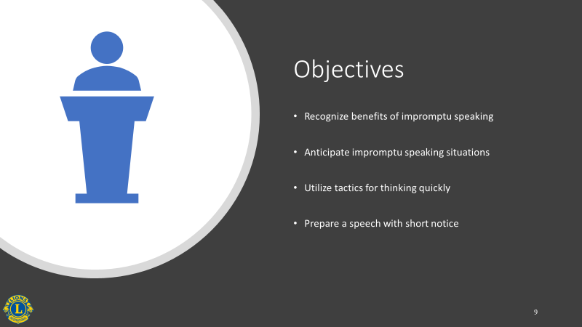
Ask
Did we meet our objectives?

State
Not many people enjoy speaking without warning or answering questions that they are not fully expecting. The uncertainty can be stressful. As second vice district governors, you are in a position that may require you to do this often. However, you now know some ways to prepare yourself for the unexpected. With practice, you can turn a stressful situation into an opportunity to impress your audience, and other association leaders, with your speaking skills and build your reputation as a leader.

Conclude the session.

